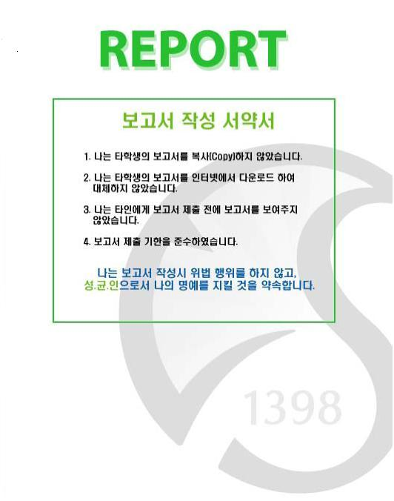

**Class: Web Programming**

**Subject: Project Report**

**Professor: Tamer**

**Major: Computer Science / Electrical Engineering**

**Team Members: 심명규 2014311788 / CS**

**신수환 2014310529 / EE**

**류호성 2015312133 / CS**

**김준현 2014312794 / CS**

**Due Date: 2019.12.19**

1. **Purpose**

The project aims to design a web page for SKKU flea market. People can register a market with 2 circumstances – Buyer, Seller. Seller can upload the products and buyer can buy their products from the site.

1. **Design Specification**

**1) Describe what is the problem**

The site implementation for each member – Buyer, Seller and Administrator are different. First, Administrator can manage member list. Administrator can see all member’s student ID, password, name, and classification, which shows if he or she is buyer or seller. In addition, they could do either modification of member’s information or member deletion.

Seller is the member who wants to sell product. So, they could do product registration. Product information includes name, price, trading place, and phone number. Also, products can be handled by auction, so seller can proceed an auction without setting a price. Also, product info could be modified or either can be deleted. In the menu, member could check their product list specifically – price and bidder.

Buyer is the member who wants to buy product. They could see the product list which seller uploaded to the site. They could check their shopping list with calculation of products they bought. The price of the auction is reflected to the shopping list when they are over. Also, they could buy product with ‘Buy’ button, or give a bid on auction. They could put their wish list also. They could search product by seller name, product name, and hope price.

On the common page, it will have login page, registration page, and product page. [1]

**2) Describe how to solve the problem**

The main HTML codes are all designed in JSP. Java is used to implement functionalities to control databases with user requests.

[Picture 1] Codes of Project

We used Colorlib template as the base for HTML and CSS files. [2] Also, we used IntelliJ IDE to build our website [3] and used to Apache Tomcat for our server.[4]

[Picture 2] Example of JSP code

1. **Function Implementation Results**
2. **Common Page**
3. **Registration Page**

[Picture 3, 4] Register Page on left and Error Page on right

In the registration page, users may put their ID, password, name, phone number, and member classification. There is also an ID validation feature as well. If an ID already exists, the webpage notifies the user that the ID already exists.

1. **Login Page**

[Picture 5] Login Page

If ID or password does not match, error message will occur.

[Picture 6] Login Page – Error Message

1. **Product Page**

Product will be shown on the product page when seller registers it.

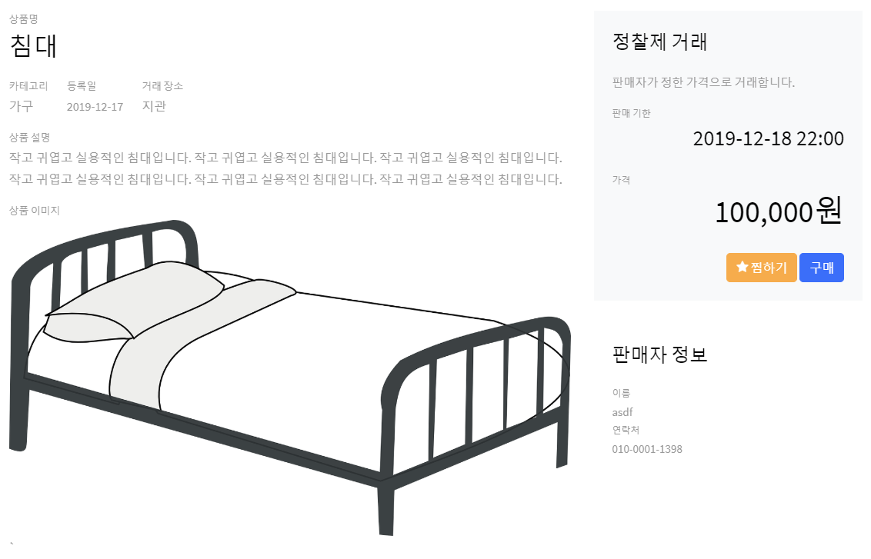

[Picture 7] Product Page

1. **Seller**
2. **Product Registration**

[Picture 8] Product Registration Page

Seller can register products with name, category, trading place, trading type, cost, due date, and simple description of product. They can attach image files, too. Phone number is registered in the seller’s user information. The seller can start the auction from 0₩ (not setting a price).

1. **Seller’s Product List**

[Picture 9] Product List Page

After registration, the seller can check his/her product on history page. After administrator’s approval, the product will be shown to all users. Also, they could check the history of auction, as well as the number of people who wants to buy their products.

[Picture 10] Product on Database

It is managed on the database sheet.

1. **Product Info**

The seller may modify or delete his/her products before the product is sold.

[Picture 11] Product Information Modification

1. **Buyer**

**1) Product list**

[Picture 12] Product List

After administrator’s approval, the product will be displayed on the product list page. Also, we could search products by options. By clicking the product, buyers can check the details of product.

**2) Shopping List**

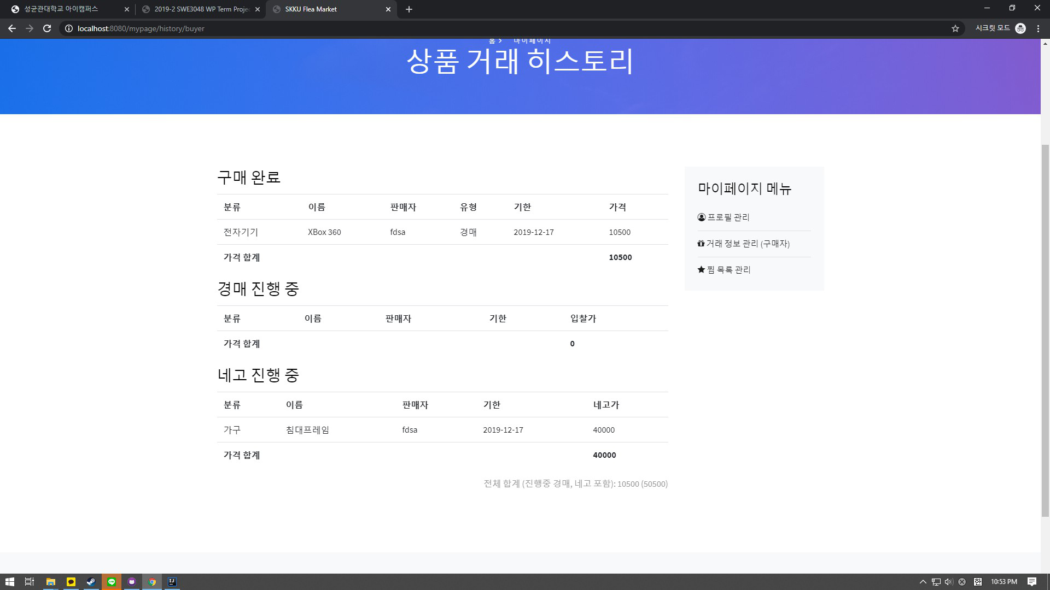

Buyers can view their shopping list on “My Page”.

**3) Product Buy**

[Picture 13] Auction Type Product

[Picture 14] Bidding on Auction

If seller as set the selling type as auction, the remaining time and cost of present time is shown. Buyer can bid the product by clicking bid button.

When the time expires, the type of the product is changed into sold out.

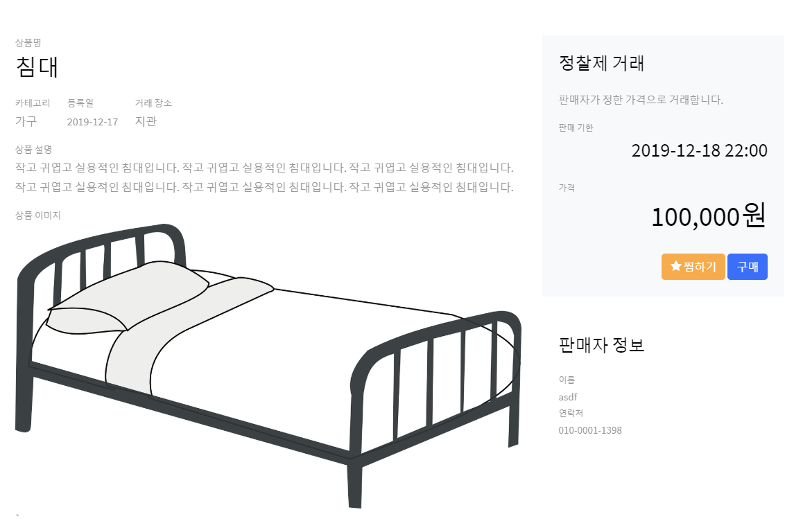

[Picture 15] General Type Product

On the general type product, by ‘buy’ button, product will be purchased and changed into sold out type.

[Picture 16] Sold Out Product

1. **Product Search**



[Picture 17] Search Bar

On search, it will display search results by product list page.

[Picture 18] Search Options on Product List page

Buyers can search by name, price and category.

1. **Wishlist**

[Picture 19] Wishlist

Wishlist can be checked on “My Page”. Buyers can remove products from the Wishlist if the buyer do not want to buy the item anymore.

1. **Administrator**

To use administrator account, put the User type should be manually set to ADMIN on the database.

(Administrator only can made by authorized user.)

[Picture 20] ADMIN Type Database

1. **Member List**

[Picture 21] Member list administration

Administrators can check ID, password, name, phone number and classification of each user.

1. **Member Modification and Deletion**

[Picture 22] Member info Modification

Administrator can modify information of member. They can change password, name, phone number, and type of user.

[Picture 23] Deletion of User

Deletion of user ID can be done as well.

1. **Extra Functions**
2. **Responsive Web Page**

The layout of the page changes by the size of the window.

[Picture 24] Responsive Web Page

1. **Search by Category**

Buyers can search things by category also.

[Picture 25] Search by Tag

1. **Profile Modification**

Users – Buyers and Sellers – can modify their profile by themselves.

[Picture 26] Modify Profile

1. **Selling by Negotiation**

[Picture 27] Negotiation

Buyers can negotiate price with the seller. If the seller accepts the negotiation price, the product will be sold at that price.

1. **Selling Approval by Admin**

[Picture 28] Approval

After the seller register his/her product, the administrator will check the product, and if it is OK, administrator will going to have an approval. If not, administrator will decline the product.

1. **Roles**

심명규: Login, Register, Main, Product page Frontend

신수환: My page, Administrator page Frontend

류호성: Product, Bidding, Wishlist Backend

김준현: Login, Register, Admin, DB Backend

1. **References**

[1] “2019-2 SWE 3048 WP Term Project Notice.pdf”. (2019). [ebook] Available at: https://icampus.ac.kr [Accessed 16 December. 2019].

[2] SkillHunt. Colorlib.

[3] InteliJ. Intel.

[4] Apache Tomcat. Apache Software Foundation.